1. download the code from github. Please send me your github email account by individual messages. please make sure you have your email set as publicly searchable.

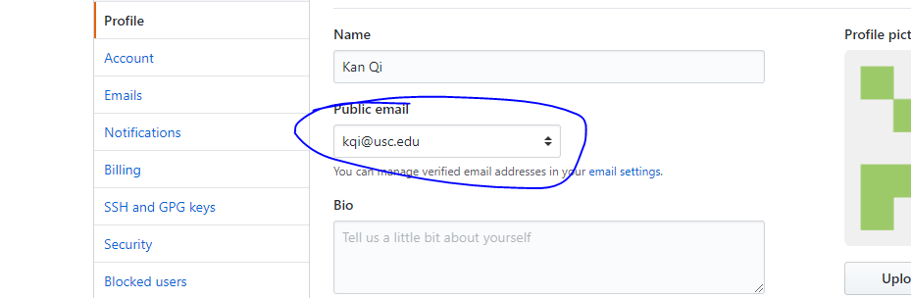

2. setup the instance on your machine, following the instructions in documents/Configuration Manual.docx

3. play with the tool. for example upload example xml files: data\577 Projects\2016-2017\XMIsV1.0\f16a_Newlette_Coins.xml. Try to understand how the system works. (edited)

Please let me know if you have any questions.